

Rosanna Cubs – Montmorency RSL
Tuesday 28th April

On Tuesday the 28th, we’re going to meet at Montmorency RSL to learn about “Their Service – Our Heritage” as part of earning the special 100 year Heritage Badge.

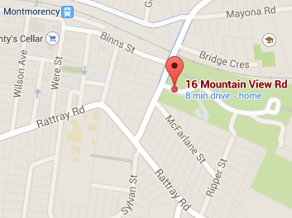
Details:
- Meet between 7 & 7:10pm at Montmorency RSL, Petrie Park, 16 Mountain View Rd, Montmorency (see map.
- Pickup at approx 8:15pm from the RSL.
Cubs will be learning about the service of our Service men and women.
For those who attend Anzac Day Services, this will complete their Heritage Badge requirements. For others, this will cover half the badge and we can advise on the requirements for the rest.
\

See you there – don’t miss it!

Regards

Akela
9434 7594
0411 121 495
akela@rosannacubs.org

See us at http://www.rosannacubs.org

